**Movie Ticketing Bot**

Krishna Priya G – Assistant Professor -Jansons Institute of Technology, Coimbatore-krishna.kcse@gmail.com

Category: IBM Cloud Application

Skills Required: ChatBot, IBM Watson Assistant, IBM Nodered

**Project Description:**

In this project, we will be building a chatbot using Watson assistant. This chat should have the following capabilities:

1. Give the list of movies available
2. The Bot should be able to show different show timings
3. When a movie is selected the bot should show the availability of tickets and their respective prices.
4. The bot should be in a position to book tickets.

**Services Used:**

1. IBM Watson Assistant
2. Node-Red

**Architecture:**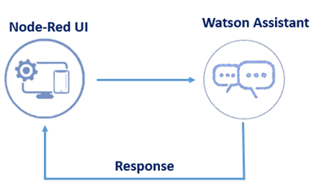

**Process flow:**

Chatbots use natural language recognition capabilities to discern the intent of what a user is saying, in order to respond to inquiries and requests. The following figure depicts the process flow of the project to build chatbot for booking movie tickets in a theatre.

**Create Watson Assistant:**

In IBM Cloud, Watson Assistant service used to build applications that understand natural-language input and respond to users with human-like conversation. The steps below creates the project to build chatbot in Watson Assistant.

1. Find the Assistant service in IBM Cloud Dashboard.
2. Click on the service and Launch Watson Assistant.
3. Create new Assistant to initiate the bot for movie ticketing
4. Create new Skill for the same

**Define Intents & Entities:**

Intent and entities in chatbots are both essential to delivering what the customers wants and needs. Intents are the intentions of the end-user conveyed to the bot. It refers to the goal the customer has in mind when typing in a question or comment.

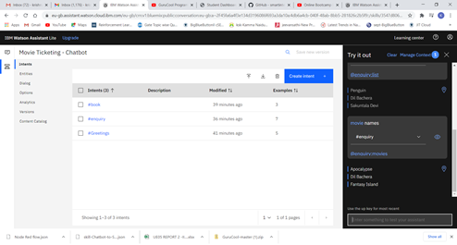

The above 3 intents are created to identify the intention of user during their interaction form movie. The intents are enquiry, Greetings and book. Every intents are trained with unique examples to help Watson understand the customer goal.

Entity refers to the modifier the customer uses to describe their issue ie., entity in a chatbot is used to add values to the search intent. The following are entities created to connect with customers.

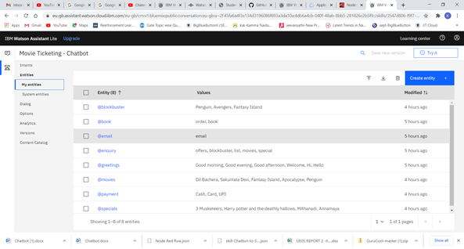

**Build Dialog flow:**

Dialog flow is a natural language understanding platform that makes it easy to design and integrate a conversational user interface into the mobile app, web application, device, bot, and interactive voice response system.

The below figure depicts the dialog flow build to shop essential items during pandemics. Totally, 5 nodes are created to welcome, greet, handle enquiry and to book tickets. Anything else node is used, if assistant does not able to recognize user input.

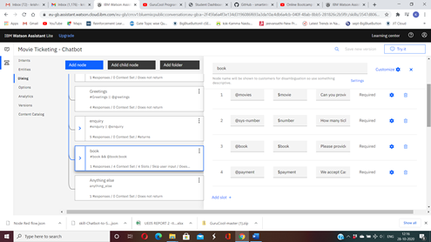

The child nodes are added under enquiry node and order node to show special offers and manage context variables.

The preview of chatbot to enquire about movie names, special movies, blockbuster movies, offers and finally booking tickets are shown.

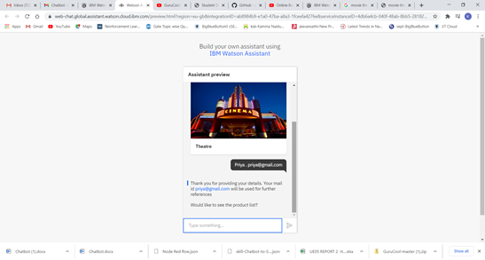

Preview of Movies and special options.

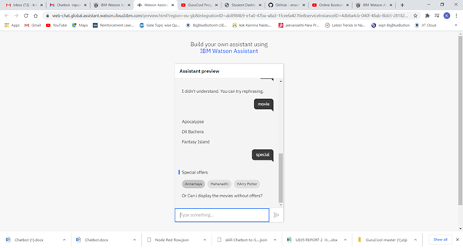

Preview of Blockbuster superhit movies. (Text and image).

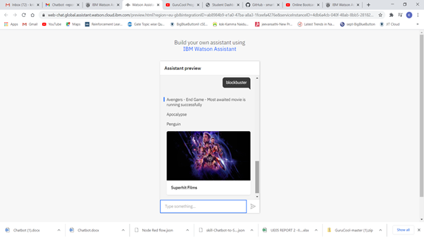

Preview of booking tickets. Chatbot enquires for total ticket count and movie name and payment method.

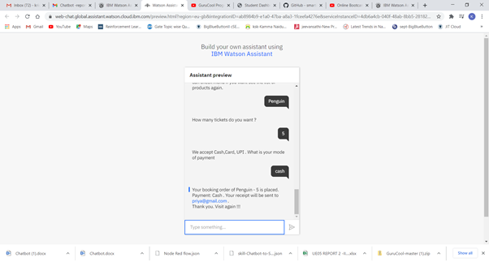

**Create and Integrate Node Red to Chatbot:**

In this activity, node-red is integrated with the chatbot by specifying the API key and scoring end point of the model. The json file of chatbot flow is uploaded.

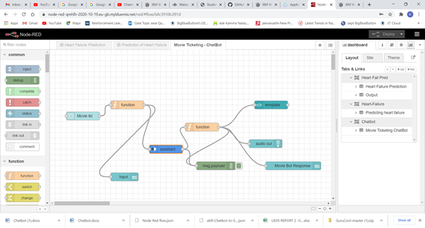

The Endpoint and API key are generated and saved to integrate the model with the application created in Node Red. The workspace ID retrieved from the chat bot skill is also updated in the assistant node of Node Red. The below figure shows the flow of chat bot. The audio out node is used to convert text to speech during conversation. Finally the flow is deployed and verified.

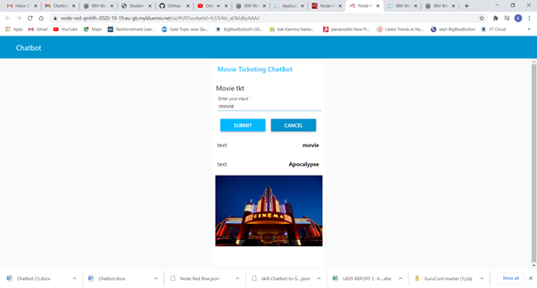

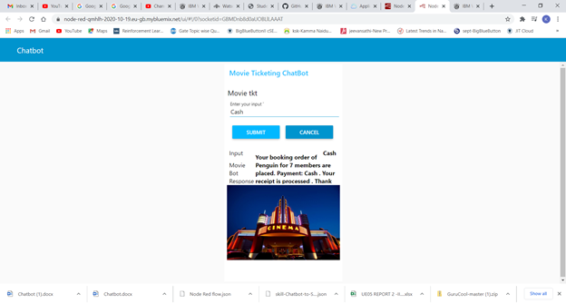

**Conclusion:**

The chatbot is built to serve the customers in theatre who enquire for tickets. It is created using the Watson Assistant and further deployed in Node Red in IBM cloud. This bot has the capabilities to provide the list of movie names, special rerun movies, blockbuster- superhit movies, offers and also finally place booking order with the given details of the customer. Along with the text outputs this bot also has audio service as a response which is much interactive.